**EXPERIMENT-13 VM**

VM IMAGE WITH 1 CPU, 2GB RAM AND 15GB STORAGE DISK

STEP -1: Create a new Virtual Machine

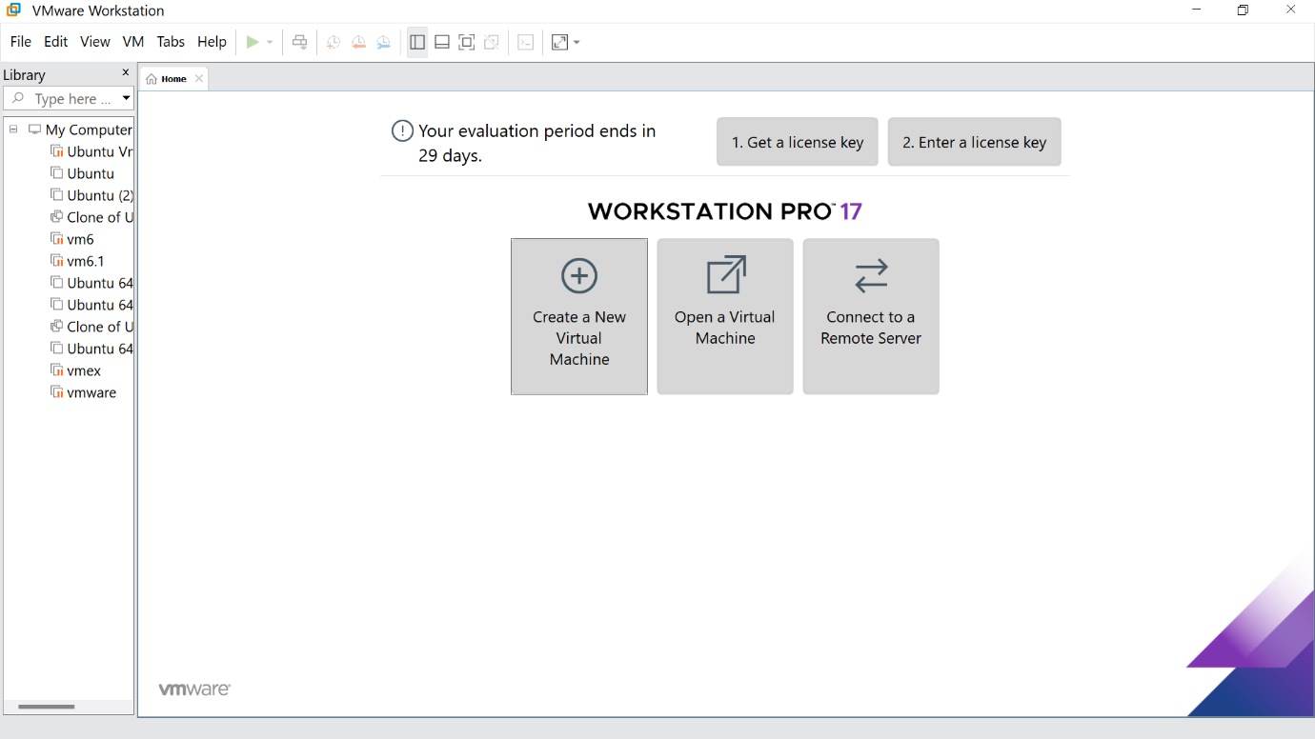

STEP -2: Click on Typical option and click Next

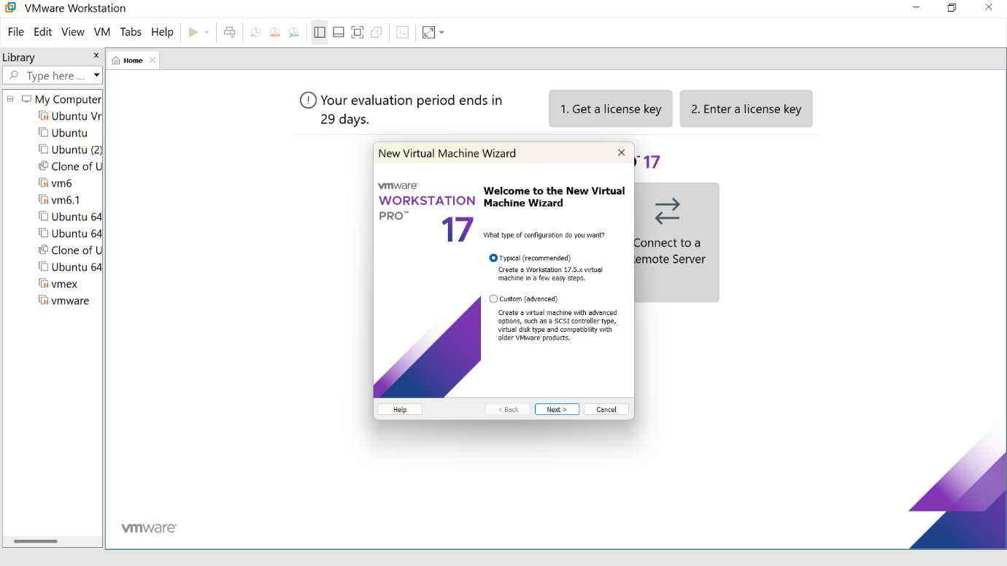

STEP -3: Click on install and browse the file you need and click next step

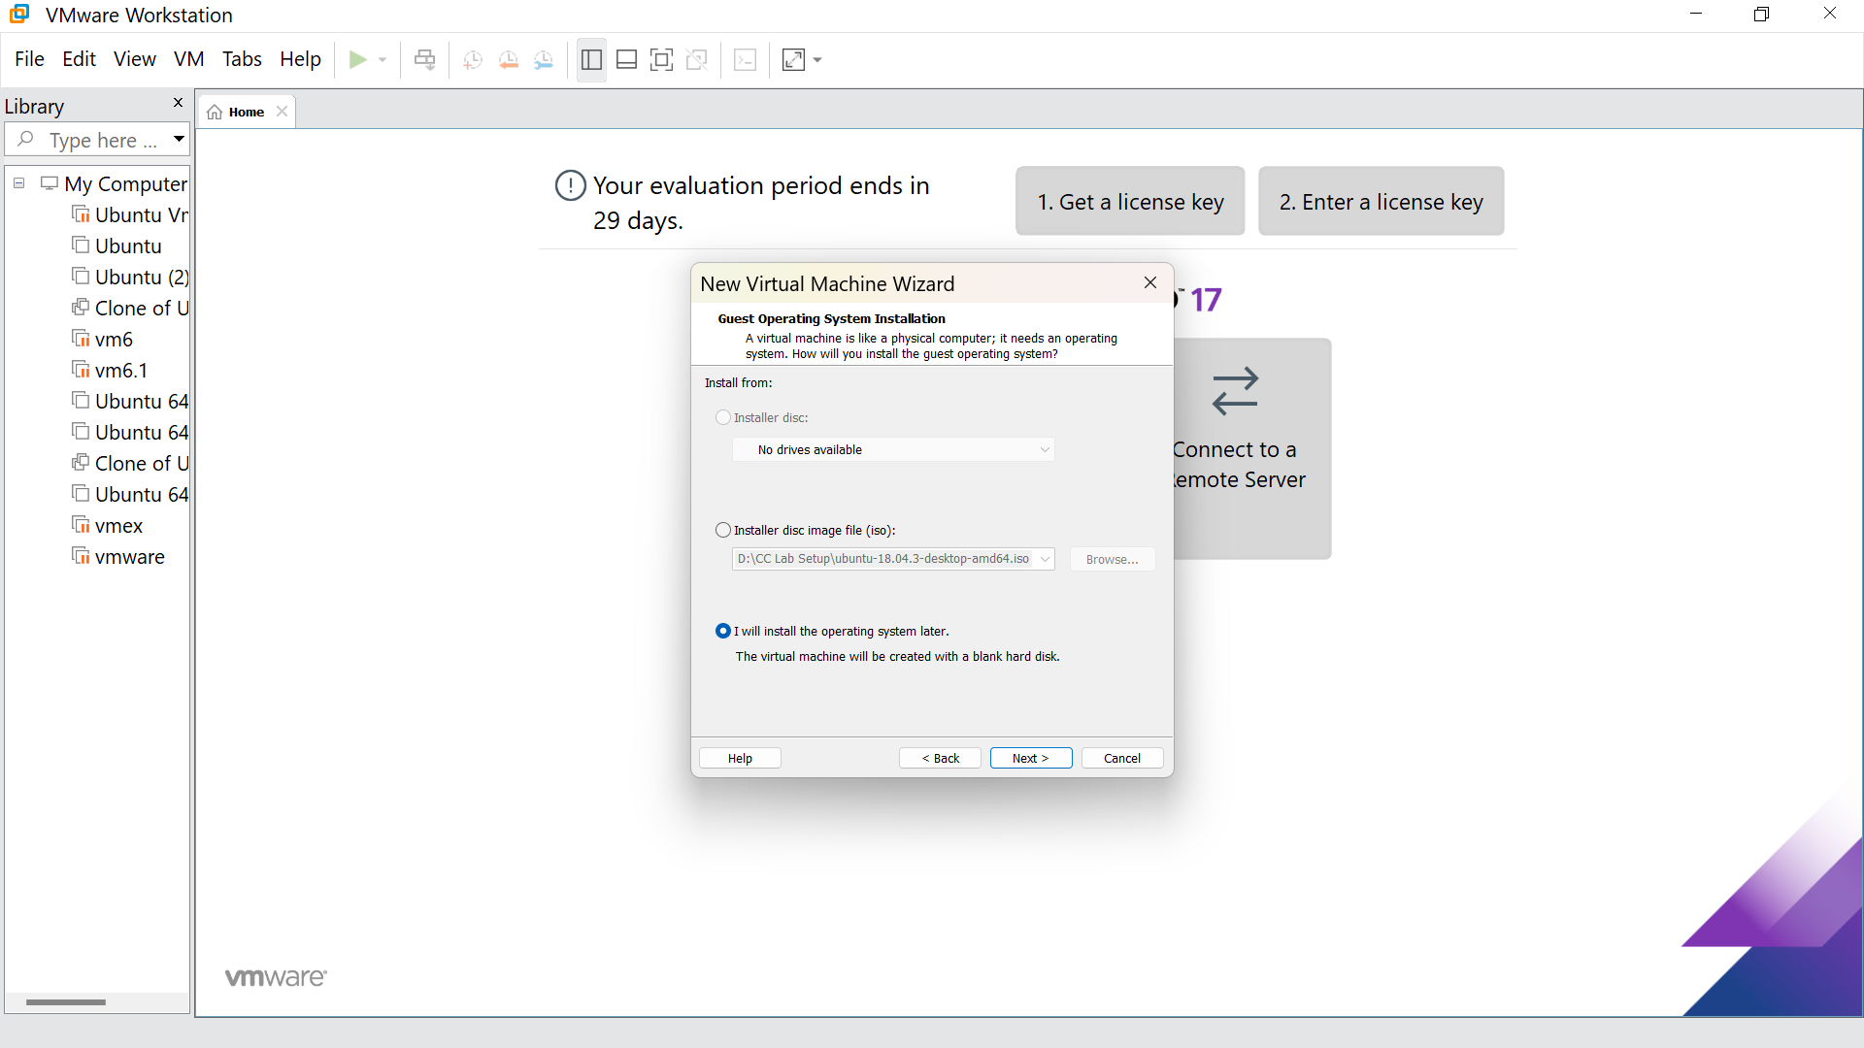

STEP -4: Select Linux option and click Next

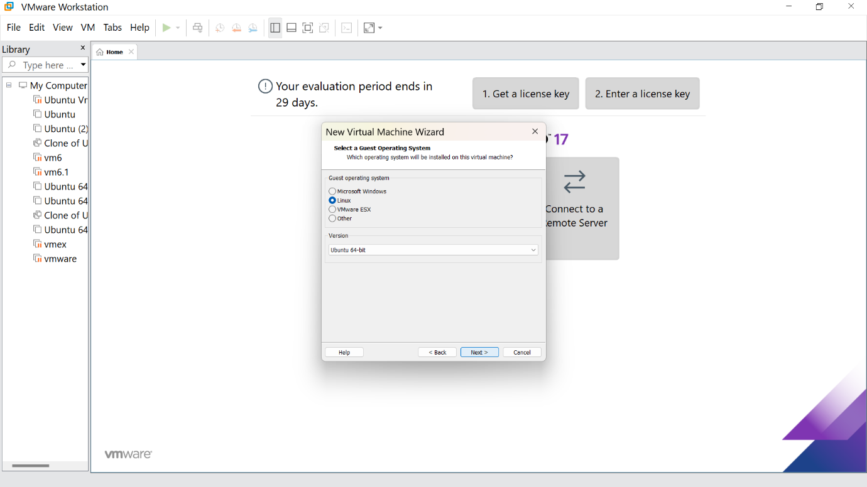

STEP -5: Give the name for the virtual machine(optional) and click next

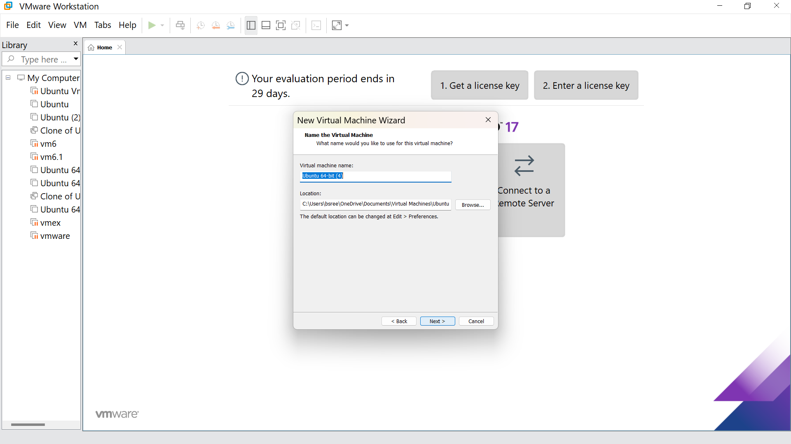

STEP -6: Give the maximum disk size as 15.0 GB and click next

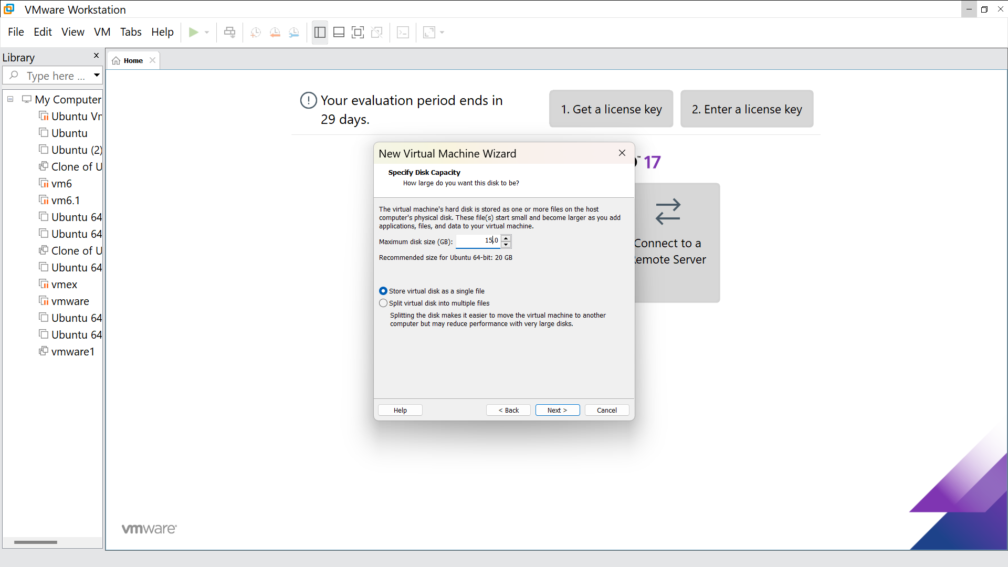

STEP -7: Our new VM is ready ,click finish

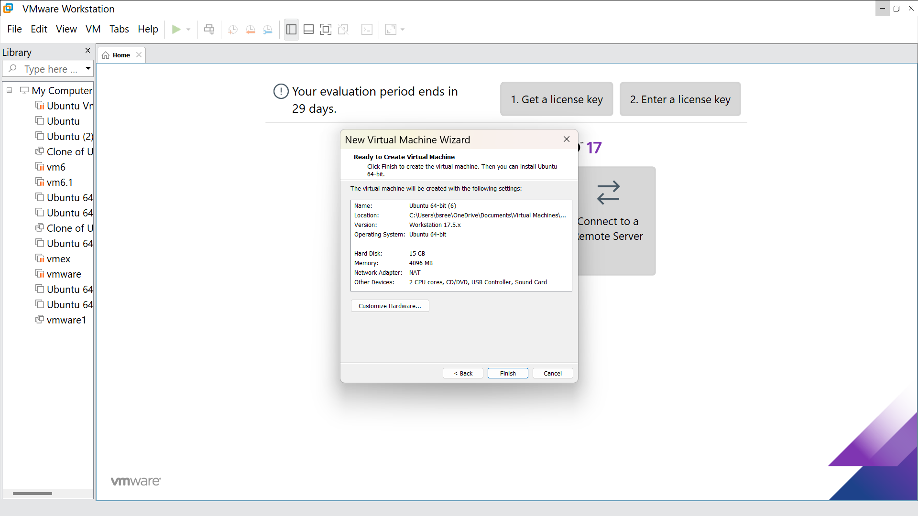

STEP -8: Go to memory and change that to 2 GB

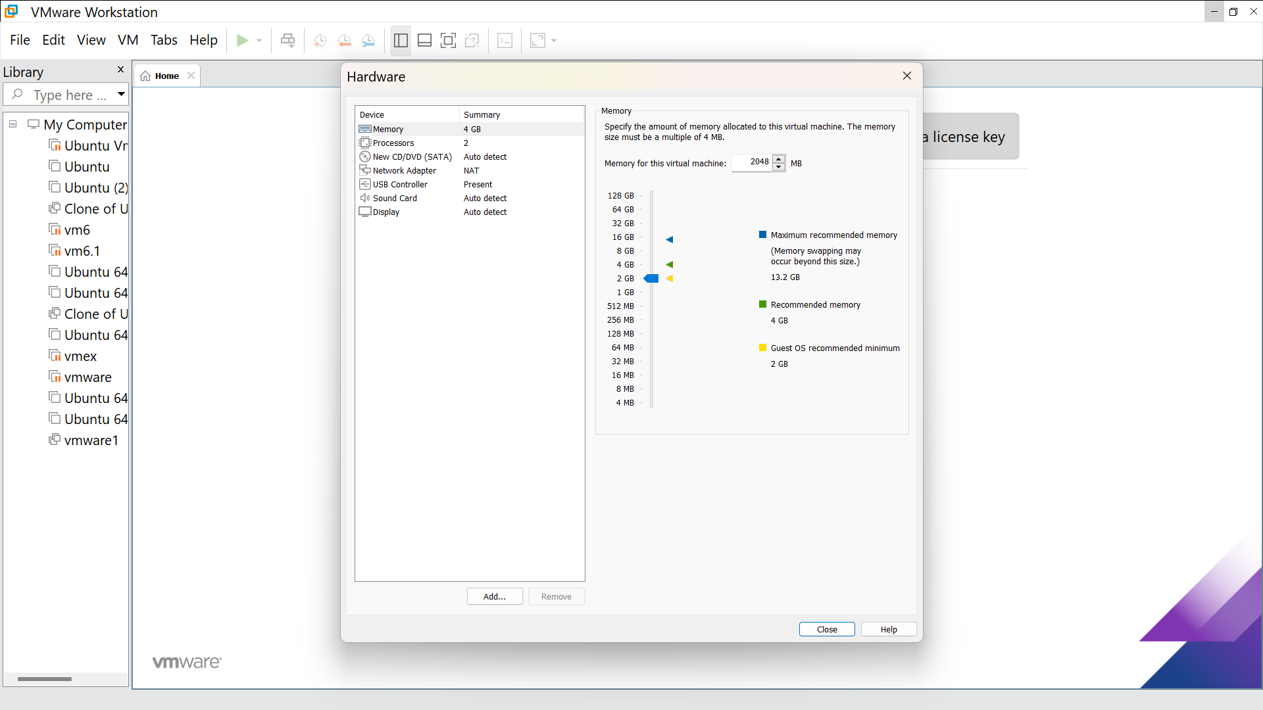

STEP -9: This is the creation of VM

